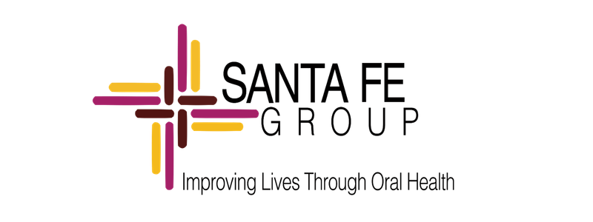

FOR IMMEDIATE RELEASE

CROSS-SECTOR LEADERS CONVENE IN WASHINGTON TO CATALYZE WHOLE-PERSON HEALTH INTEGRATION
Santa Fe Group 2026 Convening Unites Leaders Across Health Care, Policy, Education, Industry, and Community Practice Around a Shared Agenda to Make Oral Health Inseparable from Whole-Person Health

WASHINGTON, D.C., July 13, 2026 — The Santa Fe Group brought together over 100 leaders from across health care, policy, education, and community practice in Washington, D.C., June 22–24, 2026, for its landmark convening, Oral Health as a Pathway to Wellness and Longevity. Spanning 100+ organizations across dentistry, medicine, nursing, public health, academia, government, payor organizations, health systems and industry, the convening marked a concrete step in the movement to make oral health inseparable from whole-person health.

Over three days, participants moved through a structured arc — Discover, Dream, Design, and Deploy — surfacing bright-spot models of integration, co-designing bold approaches to systems change, and making personal commitments to move the work forward post-Convening. The result was not a standard conference. It was the launch of a working, cross-sector network built for shared ownership, collective action, and sustained public value.

"True health equity and longevity are impossible to achieve when oral health remains siloed from the rest of the healthcare ecosystem. What happened in Washington was a deliberate gathering of leaders prepared to break down historic barriers and build from what is already working. The energy across these three days showed that leaders across sectors are ready to move from asking why care must be integrated to showing exactly how we can collectively do it."

— Dushanka V. Kleinman, DDS, MScD, President, Santa Fe Group
Across 12 cross-sector working groups, participants identified five cross-cutting levers for systems change: education and health literacy as a foundation for shared understanding; payment and financing reform aligned to outcomes; interoperable data infrastructure and shared diagnostic codes; care delivery models that center prevention and integration; and narrative change that reframes oral health as essential to wellness and longevity .

"This convening is the beginning of our work, not the end of it. By using a framework of Appreciative Inquiry, we grounded our strategy in models that are already working. It moved us past good intentions and gave everyone in the room a shared framework to tackle systemic barriers and named commitments to act on. The real measure of these three days won't be what we said in Washington; it will be what we build in the months and years ahead — together."

— Zachary A. Brian, DMD, MHA, Founder’s Fellow, Santa Fe Group

The Convening’s third day — Deployment — turned two days of Discover, Dream and Design dialogue into accountability. Participants outlined their commitments, detailing which system areas they will focus on, the capacities and influence they bring, the partners they will work with, and precisely how they will contribute — from direct implementation and clinical practice change to capacity building, communications, data measurement, and policy advocacy.

”Integration is no longer aspirational. It’s necessary and the work to get there is just beginning.”

— Cyrus Lee, Chief Executive Officer and Executive Dental Director at Permanente Dental Group

The 2026 Convening launched the practical infrastructure for sustained engagement: a Prototype Library open to ongoing submissions, a Story Bank and Public Policy Hub for contributed voices and ideas, and a continuing collaboration structure to ensure that every commitment named in Washington has the support it needs to move from intention to action.
A conference ends when the last session closes. A convening ends when the last commitment is acted on. The Santa Fe Group invites health care professionals, policymakers, community organizations, academics, payers, private and public industry leaders, and all committed to whole-person health to join the movement at santafegroup.org/convening-2026.

About the Santa Fe Group
The Santa Fe Group is a think tank of thought leaders whose mission is to advance the integration of oral health into overall health and well-being. Through research, convening, advocacy, and cross-sector partnership, the Santa Fe Group works to ensure that the system recognizes and treats oral health as inseparable from whole-person health. Learn more at santafegroup.org.
###

Media Contact: admin@santafegroup.org | 509-731-3240

